***Fundamentals Of Programming***

***Lab Task: 08***

***Submitted to: M. Affan***

***Submitted by: Nafeel Javaid***

***Roll no: 465554***

***Course: ME-15***

***Section : A***

**Task: 01**

**.** #include<iostream>

using namespace std;

int main()

{

int x;

float s(0.0),avg;

cout<<"Enter the number of arrays: ";

cin>>x;

float arr[x];

for(int i=0;i<=x;i++){

cin>>arr[i];

s+=arr[i];

}

avg=s/x;

cout<<"The answer is: "<<avg;

return 0;

}

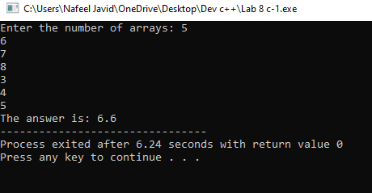

**Task: 02**

**.** #include<iostream>

using namespace std;

int main()

{

int x,y,z;

int arr[6]={9,6,8,2,10,5};

for (int i=0;i<5;i++){

for(int j=0;j<5;j++){

if(arr[j]>arr[j+1]){

z=arr[j];

arr[j]=arr[j+1];

arr[j+1]=z;

}

}

}

for(int i=1;i<=5;i++){

cout<<arr[i]<<",";

}

return 0; }

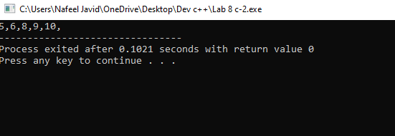

**Task : 03**

**.** #include <iostream>

using namespace std;

int main(){

double arr[10];

for(int i=0;i<10;++i){

cout<<"enter integer "<<(i+1)<<": ";

cin>>arr[i];

}

cout<<endl;

cout<<"Entered array is: ";

for (int i=0;i<10;++i){

cout<<arr[i]<<" ";

}

int n=10;

double temp;

int m;

for (int k=0; k<=n-2;++k){

m=k;

for (int j=k+1;j<n; ++j){

if (arr[j]<arr[m]){

m=j;

}

}

temp=arr[m];

arr[m]=arr[k];

arr[k]=temp;

}

cout<<endl<<endl;

cout<<"array after sorting is: ";

for(int i=0;i<10;++i){

cout<<arr[i]<<" ";

} cout<<endl;

return 0;

}



